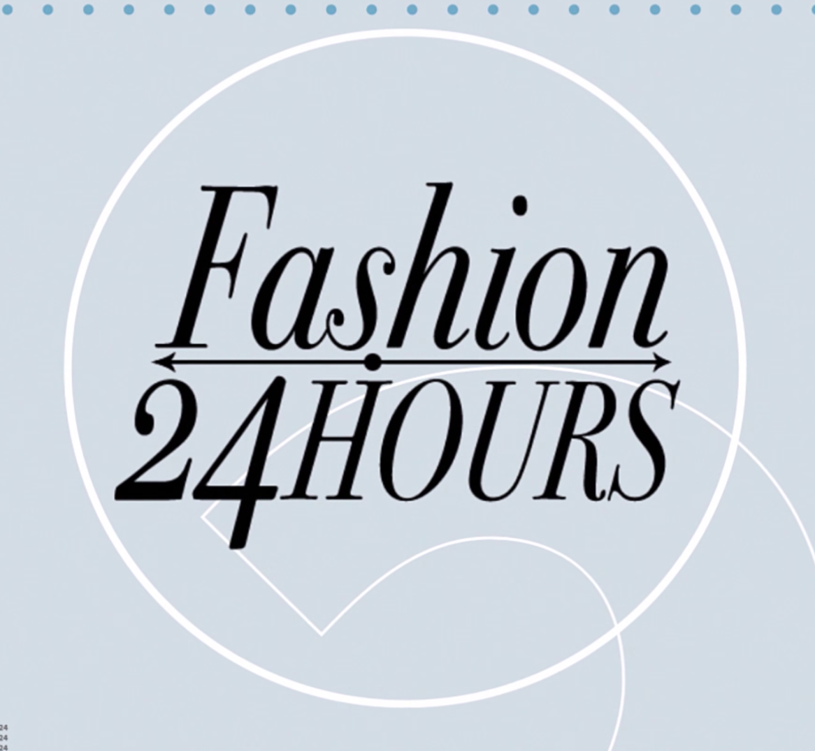

PRESSKIT

ABOUT THE SHOW

Our cameras follow a successful fashion industry professional for a day, going deep inside their glamorous daily life. From when they wake up until late into the night, Fashion 24 Hours follows famous top models, designers, stylists, makeup artists, photographers and more. Letting you into their homes, giving you valuable insider tips based on their real life experience and exposing their surreal everyday lives.
Spend the day with your favorite hard-working fashion celebrity from morning to night in one of the wildest, most intense industries in the world on Fashion 24 hrs.

EPISODE LIST

Episode 1 - MAJA SALAMON

MAJA SALAMON

Maja Salamon (born October 5, 1994 in Wodzislaw Slaski, Poland) is ranked as one of Models.com Top 50 in the world. She was discovered in 2011 bij D'vision from Warsaw and she had her big breakthrough during the S/S 12 fashion show season when she opened for Balenciaga in Paris.

She has walked in fashion shows for Christopher Kane, J.W. Andersen, Allude, Balenciaga, John Rocha, Vanessa Bruno, Louise Gray, Simone Rocha, Charlotte Ronson, Doo.Ri, Jeremy Laing, Libertine, Temperley London, Antonio Marras, C'N'C Costume National, Victoria Beckham, Zero + Maria Cornejo, Francesco Scognamiglio, Marco De Vincenzo, Edun, Steven Alan, Timo Weiland, Honor, Simonetta Ravizza, 3.1 Phillip Lim, Cacharel, Jean- Charles de Castelbajac, Thakoon, Wayne, Marchesa, Rebecca Taylor, Band of Outsiders and Billy Reid.

She has been on the cover of Vogue, Elle and D’Scene, has done campaign work for Reserved, Prada, Hugo Boss, MAC, Vera Wang, Carven and others, has been shot for editorials in i-D, Elle Poland, Fashion Magazine, Viva! Moda, Vogue UK, Tatler, L'Officiel, Twoj Styl, Pop, Madame Figaro France, and Elle Italia, among others.

She's currently signed with D'vision in Warsaw and with Next Models in New York, London, Paris and Milan.

A Day in the Life of Maja Salamon

06:01 – Wake-up & Breakfast
A Healthy breakfast goes a long way in such a busy day.
07:28 – Exercise & Training
Running is her passion and she got a medal in finishing a marathon. Maja rides a bicycles going to McFit Gym where she has her fitness training with personal trainer, Tadeusz Gauer.
09:22 – Fitting at Vitkac
Meets with fashion stylist, Marta Sinilo, at Vitkac Luxury Department Store where she goes in for a fitting for an editorial shoot that will be shot in a few days.
10:27 – Meeting with Friends
Whenever she’s in Warsaw or anywhere in the world, Maja takes time to meet with friends. Today she meets with close friends - model, Magdalena Jasek of Society Management New York, and make-up artist, Marianna Yurkiewicz.
12:12 – D'vision Model Agency
Maja drops by D'vision Model Agency to talk with one of her bookers for her schedule and get her ticket for her shoot in Kraków.
12:47 – Warsaw Central Railway Station
With all her bags packed, Maja arrives at the Warsaw Central Railway Station for a train ride going to Kraków, Poland for her next shoot.
15:17 – House Campaign Photo Shoot.
Maja takes on House Brand Campaign Photo Shoot with model, Leo Nessim from Next Management Miami, under the direction of creative director W P Onak of OCR Creations.
18:04 – House Campaign Video Making
Right after the photo shoot, the campaign is followed by a video shoot for House’s high-intensity fashion film.
22:07 – Old Town Kraków
Maja takes us for a walk at Old Town Kraków, also known as the party city of Poland. She strolls around taking in the sights and sounds before leaving for her next flight.
23:45 – Back to the Hotel & Flight Out
Losing track of time, Maja goes back to the hotel, packing quickly to catch her next flight, which will leave in 2 hours. She’s off to the airport for her next city destination.

Episode 2 - MARTA SINILO

MARTA SINIŁO

Marta Sinilo is a talented fashion designer and stylist living in Warsaw. She finished Art Academy in Fashion at St. Martin’s College in London and works as a freelance stylist for various fashion magazines including Glamour, Elle, InStyle, Harper’s Bazaar, and many others. She also designs clothes based on her day-to-day style.

Ever since Marta was young, she wanted to do fashion. Things went naturally with her from her studies then her profession as her main focus was really on fashion. She takes inspiration from people, events, movies, music, and even the weather. Her favorite fashion designer is and has always been John Galliano. Her goal is to someday style and create costumes for movies and eventually venture into haute couture.

A Day in the Life of Marta Sinilo

05:00 – Waking up with a Healthy Breakfast
Her boyfriend, Michael, wakes her up every morning and even prepares her breakfast every single day. She used to just drink coffee but now she eats healthy and switched coffee to green spinach shake.
06:10 – Getting Ready for the Day
Have 20 minutes to get ready for her morning ride with the horses. She rides them every morning.
07:00 – “Szarza” Stud
Nothing beats an early morning ride with her favorite stud before going to work. She’s been riding horses since she was 12. She bonds together with her friends who also ride horses.
10:15 – Work Day Starts
Marta is back in her apartment to start her workday. She gets her makeup done and discusses a secret project with makeup artist, Patrycja Dobrzeniecka.
11:35 – Copernicus Science Centre
She goes to Copernicus Science Centre for a photo shoot of her for her blog with photographer, Andrina Peric. Marta also takes this opportunity to try out the clothes before she dresses it up on a model.
12:40 – Stanislaw Markiewicz Viaduct
Location no. 2 of Marta’s Blog photo shoot
14:50 – Back to Apartment
After the shoot, she goes back to her apartment to update her blog site www.fashionstyle.pl with new articles on fashion style and tips. She works with her fashion editor and assistant, Natalia Chomik.
16:25 – Backstage Preparation at Harper’s Bazaar Fashion Show
It’s the backstage grind at the Harper’s Bazaar fashion show that involves working with 20 different designers. Marta is in charge of dressing up and styling the models for the show.
21:00 – Harper’s Bazaar Fashion Show
It’s Showtime! Harper’s Bazaar Fashion Show begins and Marta is as busy as ever making sure everything is running smoothly with the clothes the models are wearing
00:45 – It’s a wrap!
And the day is done. Marta grabs a bite and heads home after a very busy day.

Episode 3 - DARIIA DAY

DARIIA DAY

Dariia Day is a makeup artist based in Paris. She was born in Poland and grew up in little town called Boleslawiec. Working in fashion industry was her childhood dream and her dream came true. She has been trained at Murza & Sokolowska Academy in Poland and took her Master program at MKC Beauty Academy in Hollywood, California. You could see her work in magazines like Vogue, Vanity Fair, Harper’s Bazaar and Numero. Her clients include Louis Vuitton, Balmain, Chanel, Dior and La Vogue, as well as celebrities like Emilia Clarke, Michael Fassbender, and Simon Baker.

Aside from her day job, Dariia established her own blog site, Beauty Lessons with Dariia Day, where she shares all her learning and experiences in the fashion industry. She also showcases makeup tips and tricks tutorials making the ritual a pleasure and fun!

LaMode tagged her as “One of the most wanted makeup artist from Poland” and Elle Magazine’s “One of the most talented in New Fashion Generation.” Dariia is indeed a driving force and a rising star in the Makeup Industry.

A Day in the Life of Dariia Day

05:30 – Waking Up & Breakfast
Dariia gets ready for a very busy day with a cup of coffee on hand. She shows us her daily beauty routine from her skin care regimen to her simple natural look make-up. She sits down for a quick healthy breakfast before leaving for the office.
07:30 – Dariia’s Office
First order of the day: replying to hundreds of emails from clients. Recently she started her own beauty brand that has been taking raves from Vogue Paris and Vanity Fair as well as celebrity endorsements.
09:15 – Getting Ready to Fly Out
Dariia takes a quick detour to her house for her luggage to take with her to Paris.
13:40 – Pont Neuf, Paris
She finally arrives in Paris and takes a short stroll along Pont Neuf
14:00 – Rue de L’Amiral de Coligny
Dariia wants to show us around more but she has two photo shoots to do.
14:20 – Vogue Magazine Photo Shoot
Her first photo shoot is for Vogue Magazine Cover Story with model Julia Banas from Elite Model Management Worldwide. Vogue Portugal’s creative director, Paulo Macedo, directed the shoot.
17:55 – Palais Du Louvre, Paris
Dariia just finished her first shoot and takes us for another tour of Paris on her way to her next shoot.
18:25 - Vogue Magazine Photo Shoot Number 2
She’s off to the next photo shoot, also for Vogue Magazine.
23:25 – Puteaux, Eugene Eugene
Finally, Dariia ends her day with a dinner at her favorite restaurant in Paris, Eugene.

Episode 4 - MICHELLE DU XUAN

MICHELLE DU XUAN

Michelle Du Xuan is a talented fashion photographer and filmmaker from the south of China, who is currently based in Paris, France. Her work includes a lot of fashion, editorial, beauty, portrait and commercial photography. She has collaborated with magazines like Vogue, Numéro, Elle, Harper’s Bazaar, L’Officiel, among many others. Her clients include Dior, Chanel, Bvlgari, Louis Vuitton, Gautier, and many more.

When Michelle moved to Paris, she met an American photographer who introduced her to the world of fashion. She then decided to start a career in fashion photography. Her photo style combines the codes of the French and Chinese culture, paying special attention to the color treatment and the simplicity that allows her to represent the emotions of her subjects.

A Day in the Life of Michelle Du Xuan

05:30 – Hotel les Estangs de Corot –Ville D’Avray
Good morning! We are starting early for a busy whole day ahead. Michelle prepares, and checks her camera and gears before heading down the hotel breakfast buffet. Fruits and fruit juices are her go to food for a healthy breakfast.
06:45 – Etangs de Ville-D’Avray
Michelle takes her workout in the park with her personal trainer and trainer of celebrities, Johnny Alvares.
08:57 – Meeting with Model Scout
Michelle meets with her friend model scout, Marko Obradovic of The Model Gene, to introduce his new talents. Does an impromptu photo shoot of new model for pooling.
10:47 – Le Chateau De Versailles
Location scouting in Le Chateau De Versailles, Michelle did some test shots and comes up with a story, mood for the next photo shoot.
13:40 – Pont Neuf, Paris
Michelle comes back to Paris and takes us on a tour around Pont Neuf and talks about how Paris has inspired her to stay and work there.
15:35 – A Ciel Ouvert Studios
Michelle takes us to her photo shoot at A Ciel Ouvert Studios with French model and actress Gaia Weiss from the hit TV series Vikings.
22:35 – Restaurant le Corot
Finally time for dinner! Michelle takes us to her favorite restaurant to end the very productive day.

Episode 5 - ‎ELISABETH VISOANSKA

ELISABETH VISOANSKA

Elisabeth Visoanska is a businesswoman and the founder of luxury skincare brand, Visoanska Paris. With Polish roots and an educational background based in France, she created the brand, not long after she headed to Paris for the first time to pursue an MBA in international luxury brand management. Growing up, Elisabeth had very sensitive skin. This drove her passion for skincare and she has sought for ways to combat it.

Visoanska Paris skincare line is considered as “haute cosmetique” designed for the most discerning clientele. The brand has been featured in several international luxury magazines like Vogue, L'Officiel, Elle, Cosmopolitan, InStyle, Glamour, Marie Claire, Harper’s Bazaar, Harrods Magazine, and Madame Figaro.

A Day in the Life of Elisabeth Visoanska

06:15 – Fontainebleau / Chateau de Montmelian
Elisabeth welcomes us to her weekend getaway place in Fontainebleau, the Chateau de Montmelian. Just a stone’s throw away from Paris, the place is full of nature one can relax and take a break from the city life. During her extra time, she spends it with nature, like gardening.
08:00 – Le Parc de Montmelian
Elisabeth shows us her green house where she does her gardening and teaches us her techniques. She adapts the Japanese art of Kokedama in arranging her plants.
09:30 – Meeting with Yves
She has her regular morning session with her consultant in innovation, Yves-Andre Morin. They talk about which direction they should take the company. Both have worked together for 12 years now and shares the same vision on the future of cosmetics.
11:00 – Paris / Rue des Francs Bourgeois
Now back to the city, Elisabeth takes us to the Rue des Francs Bourgeois, also known as the cosmetic laboratory of Paris where top cosmetic brands line up the streets. Her shop is also strategically located near the place. The Visoanska Paris brand is the pioneer of luxury cosmetics. They use only noble active ingredients and are 100% natural that are good for the skin. Mastering the craft using the most modern technology, 30 of which are patented by the company.
12:15 – Place des Vosges
One of the oldest places in Paris, Place des Vosges is where Elisabeth’s office is located. There she meets her product manager, Sebastien Mendes, to evaluate the samples that came directly from their laboratory. She goes through each and every one of the products from the content to the packaging, making sure they are perfect before being released in the market.
13:15 - Office
Still in the office, Elisabeth goes through the fashion magazines where her product ad placements and interviews are published.
14:30 – Boutique – Rue de Turenne
Being an ambassador to her brand and skincare influencer, Elisabeth is often asked to model and be featured in publications. She does a photo shoot from within her shop to the street of Paris.

16:45 – Quai de Grenelle
Elisabeth meets with interior design artist, photographer and art director, Marjan Denkov, to discuss design concepts for the store. His works are custom made designs made from luxurious materials that are specific to Elisabeth’s taste as well as the band.
18:20 – Rue Francois 1ER, Courreges
Visoanska Paris is the official partner of the Oriental Fashion Show in Paris for a few years now and Elisabeth goes to French designer brand, Courreges, to look for her next outfit.
20:45 - Fontainebleau / Chateau de Montmelian
After a long day, Elisabeth goes back to Fontainebleau for family dinner. There we are introduced to her daughter, Laura, and her fiancé, Jean Stanislas Orlowski, whose family owns Chateau de Montmelian for over a hundred years. Both are very good cooks and prepared dinner for all, with Yves as their guest.

Episode 6 - YULIA LOBOVA- HARFOUCH

YULIA LOBOVA- HARFOUCH

Yulia Lobova-Harfouch is a high-fashion model who has worked with the biggest fashion brands in New York, London, Milan and Paris. She has walked on the runways of Alexander McQueen, Dries Van Noten, Yohji Yamamoto, Lacoste, Kenzo, Rodarte, Chanel, Emanuel Ungaro, Jil Sander, Simon Rocha, Junya Watanabe and Jean Franco Ferre shows. In 2011, Vogue Paris listed Yulia as one of the best models from Russia after opening the Hermes show that year. Straight afterward the famous photographer, Willy Vanderperre shot her for W magazine but you can also find her on the pages of L’Officiel, Vogue, Harper’s Bazaar, and Elle magazines. Yulia studied fashion design and style at the International Fashion University (ESMODE) in Paris, 2013. Recently, she is a professional freelance stylist.

A Day in the Life of Yulia Lobova- Harfouch

08:15 – Yulia’s Apartment
She starts her day early by doing some online research for styles on her next shoot. She wants to always be prepared.
10:15 – Saint Ouen/Rue Des Rosiers
Yulia steps out of her apartment/office into the trendy market at Saint Ouen to look for vintage items that she might be able to use in the shoot.
10:30 - Saint Ouen
She finally made a stop in a quaint vintage shop to pick up the materials she has previously ordered. Yulia also takes a look at other items such as vintage Chanel jewelry and clothes.
11:45 – Restaurant Ma Cocotte
Yulia takes a quick lunch at one of her favorite restaurants, Ma Cocotte, at Saint Ouen. The long lines shows how famous this place is and people don’t mind waiting and falling in line to dine in.
12:50 – Les Merveilles de Babellou
Yulia makes another pick-up of a couture dress from a designer in Serbia. The flea market is a good way to find vintage clothes. It inspires her styling with the richness of culture and history that she can find in the place.
13:40 – De Laurentis Paris
Checks out more vintage clothes for styling the photo shoot.
16:50 – Yulia’s Apartment
After a whole day looking through the vintage stores, Yulia goes back to her apartment to mix and match all the items she got. She also gets a chance to show to us her lifestyle and design aesthetic when it comes to styling not just for clothes but also her place.
17:40 – 3 Rue Meyerbeer – Women Management Paris
Yulia drops by her modeling agency, Women Management Paris, to do some composites and check upcoming works with her booker, Malek Baouche.
18:25 – Yulia’s Apartment
Yulia gets ready for her presentation. She prepares the looks she is proposing to Elle China for the feature. The Elle China fashion editor, Fangfang C, with photographer, Edoardo de Ruggiero, drops for a test shoot showing her style for consideration in their future bookings. Looks like the clients are impressed.
22:45 – Arc de Triomphe
Yulia ends with a tour at Arc de Triomphe, duly representing the success she has in this fruitful day.

